**Issue #8:**

**Desc:** Ability to add Text to Long Text on Work Order and Notification – just add – don’t change current Long Text

**Required Fix:** Update long text:

* Allow update of Long Description, this would allow notification updates that would add clarity of issue. Need to append to long text.

To duplicate:

View Search notification

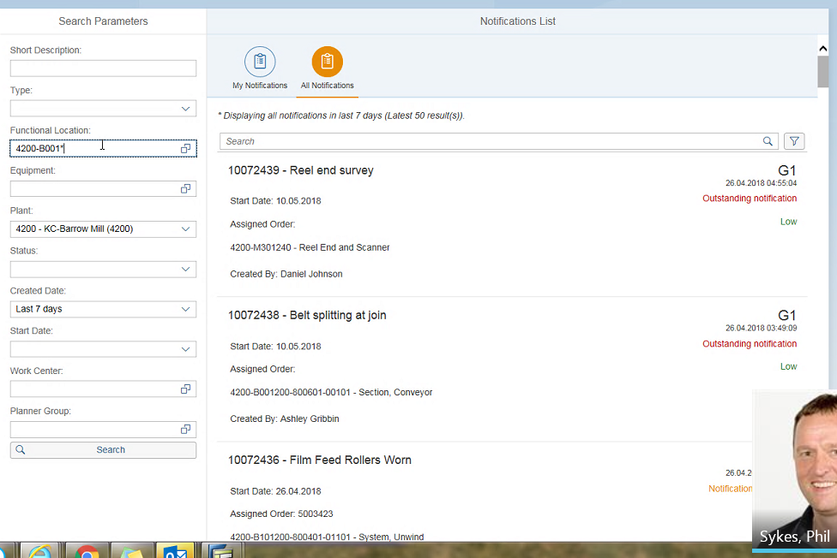

Open Notification Long Description to appending more incident details, allow for save of details.

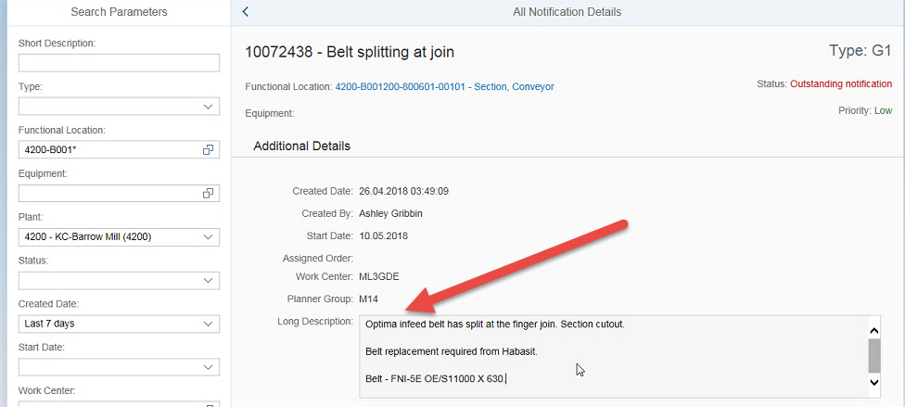

**Issue #15:**

**Desc:** When opening multiple selections is it possible for the screen position to alter itself? It would be helpful if the screen moved up so I could view the next levels below without using the slide bar. Expand to whole screen - move the screen up or down as needed to eliminate scrolling

**Required fix:**

Keep position of screen, versus starting from top, when a Notification is selected but deemed incorrect. The user would like to continue to scroll from the current position, versus screen being refreshed and user is required to scroll down from the top of the screen.

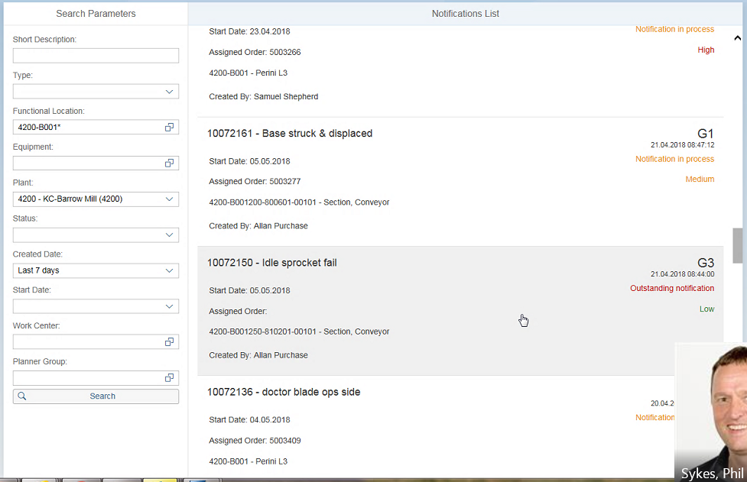

**Issue #19:**

**Desc:** If you scroll down and open up a notification then close / press the back arrow then it defaults back to the top of the search...... the screen needs to freeze when switching to make navigation easier. Don't scroll to top

**Required Fix:** After talking to Phil, he didn’t realize that to open the FL detail, the proper solution would be to click on . Versus clicking on other details of the displayed line. To help draw attention to the proper selection if  could be made bigger or somehow draw attention the proper selection.

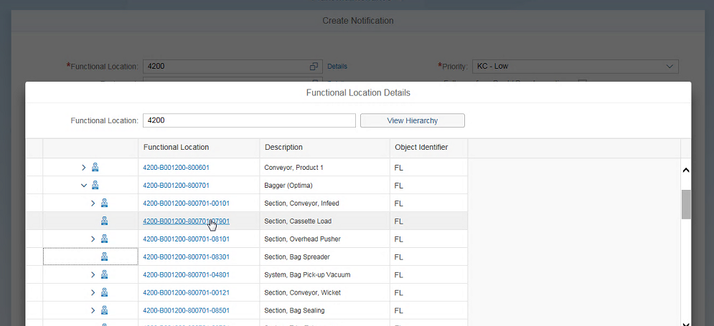

Make Icon Bigger

Separate and make bigger if possible.

 and C:\Users\q07999\AppData\Local\Temp\SNAGHTML14b2429.PNG

**Issue #22:**

**Desc:** The storage Bin isn't displayed until the order is printed. When searching in stores and unsure the user needs to go into the GUI to be able to go and check the parts......

**Create**

Search materials

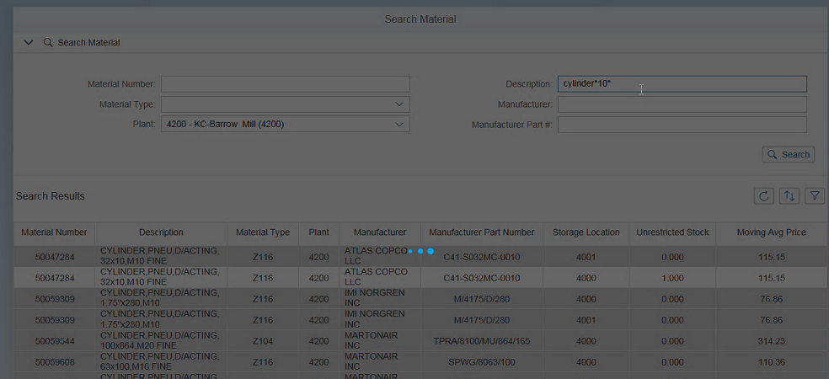

Display both Bin and SLOC, Add Bin to right of SLOC

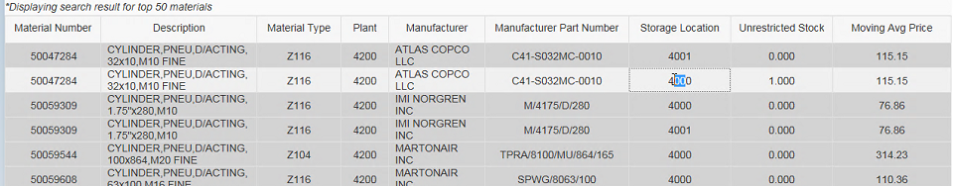

If needed plant can be removed

**Issue #26:** – Search WO

**Desc:** Indication Material is Picked - On Material Tab.

We will need to get more details from Phil, provide options to resolve the issue. ISSUE that needs to be resolved is to indicate the status of the material. They are having issues with the same part being picked twice, causing stores issues.

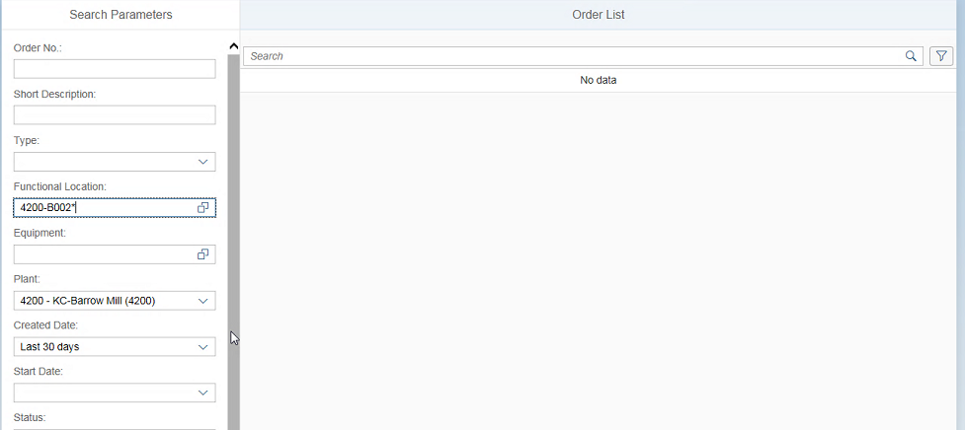

Indicate material has been picked.

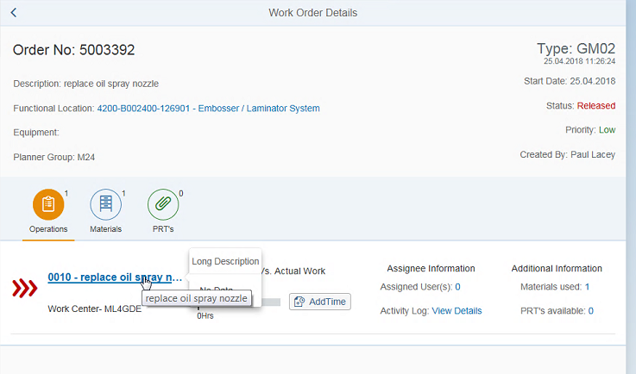

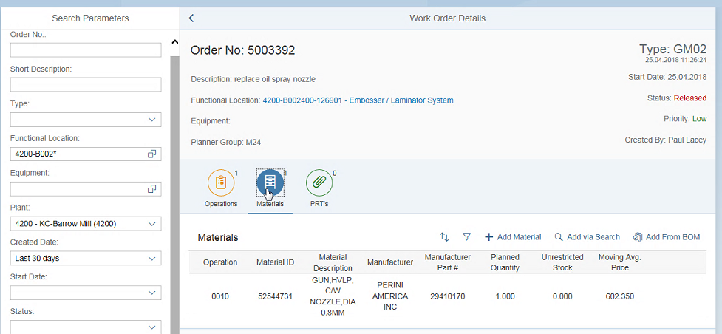

Some status describing showing the status of part, has it been picked?